MOLD TECH VS YS: A Comprehensive comparison of mold textures

# Introduction

There is always some sort of imperfections on the mold surface due to various factors like injection molding parameters, different physical and chemical properties of the polymer blends, shrinkage, contamination, etc. That’s why most plastic product needs additional treatment to improve the surface finish. When it comes down to the aesthetic appeal of the product, surface finish becomes a critical aspect. Surface finish, also known as surface texture, is the overall texture of the surface determined by the three characteristics of lay, surface roughness, and waviness. Mold texturing is one of the crucial processes in manufacturing industries when producing parts made up of plastic, glass, metal, and ceramic through various molding techniques. The major advantages of mold texture are improved appearance, reduced creases, and enhanced grip. Along with the aesthetics, it also contributes to hiding imperfections like flow lines, sinks, burn scars, etc. Mold texturing also provides functional benefits like strength and enhanced adhesion to the product. The other benefits of mold texturing are improved mold release, branding, and the creation of parts that mimic natural materials like wood, rock, leather, etc. Trade associations like the Society of the Plastics Industry (SPI) and the Society of German Engineers/ Verein Deutscher Ingenieure (VDI) determine the standards and designation for the molding finish and textures. Mold-Tech (MT) and Yick Sang (YS) are the two companies that have developed their own standards.

# Understanding mold textures

Mold texturing is the process of creating various patterns, textures or designs on the product's surface. The purpose of mold texturing is to impart a distinct appearance to the final product during the molding process. The appearance can range from simple patterns like grains or dots to complex designs that mimic natural materials, such as wood, leather, or stone. Mold texturing plays a significant role in enhancing the visual appeal, functionality, and differentiation of molded products. Generally, Mold surface texturing is done by five common methods and they are:

1. Sanding and polishing:

Machining operation always leaves behind some tool marks on the workpiece. So, these tool marks should be removed before transferring the workpiece to injection molding. Sanding and polishing are done to remove those marks and other surface imperfections by the technicians using rotary tools, sandpapers, and other abrasive papers. The factor to consider while sanding and polishing is not to exceed dimensional tolerances.

|  |  |
| --- | --- |
| Figure : Polishing (source: https://www.mirka.com/) | Figure : Sanding (source: https://sandpaperamerica.com/) |

1. EDM Spark erosion:

It uses graphite or copper electrode immersed in an electrolytic bath of water or oil. When the electrode receives its threshold current, it sparks against the tool wall. This process melts the targeted body and is immediately quenched by the surrounding electrolyte. Thermal shock is generated which causes the metal to fragment into tiny particles and they are flushed away. It is applicable for hard and soft metals which required very tight tolerances.

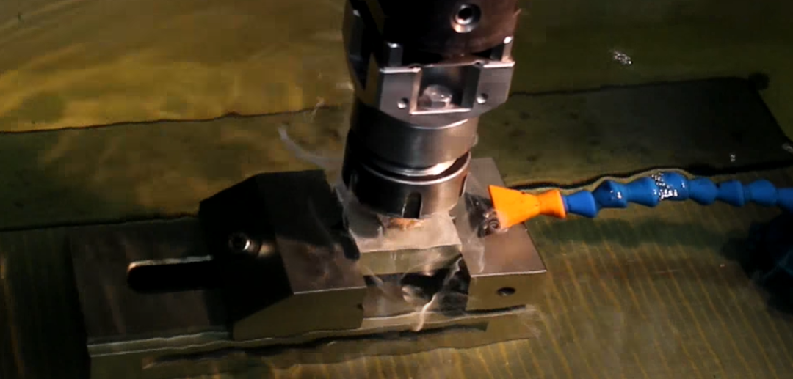

Figure : EDM (source:https://www.youtube.com/watch?v=9oPmFb4liVM&ab_channel=EDMPrecision)

1. Media Blasting:

High-pressure air sprays are used to transfer abrasive media (e.g., sand, beads) on molds, achieving a uniform matte or satin finish. It is controlled by skilled operators. This process is very fast, cost-effective, and minimal waste. It Allows distinct textures without overlap.

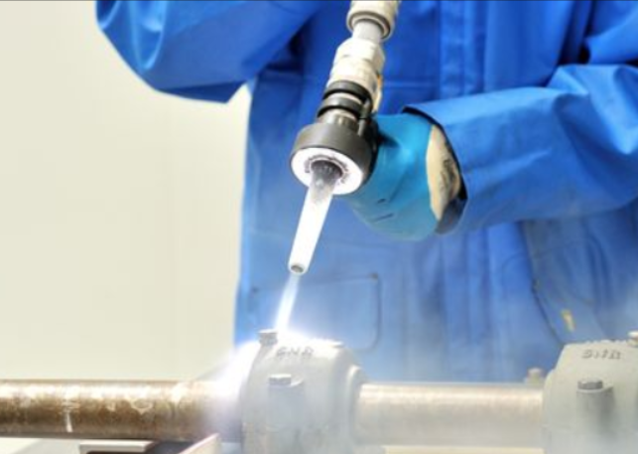

Figure : Media blasting (source: https://www.cnclathing.com/guide/what-is-abrasive-blasting-or-sandblasting-cnclathing-metal-surface-finishing-services)

1. Chemical photoetching:

Photoetching applies patterns to mold tools by coating them with light-sensitive photoresist and then projecting desired patterns with UV light followed by etching in acid baths and creating textures. The process is fast, cost-effective, and fine details, but limited by undercuts and curved surfaces.

1. Laser etching:

Laser etching is the process that allows mapping textures onto curved surfaces using 3D computer modeling for precise alignment and 5-axis motion control for accurate tracking, even in undercuts. This method is very common in automobiles for consistent long-length patterns despite its higher costs and longer setup time.

The roles of mold textures in product design and functionality are listed below:

* Aesthetics and branding
* Product realism
* Grip and functionality
* Enhanced surface quality
* Differentiation in the competitive market
* Optical properties like anti-glare or light diffusion
* Wear resistance

# Mold-tech (MT) mold textures

## History and Background

Standex Engraving Group, affiliated with Standex International Corp, is a prominent texture development enterprise. It was founded in 1955 and is headquartered in the US. Mold-Tech is a subsidiary of Standex group that has boasted 33 texturing facilities worldwide. Since entering the Chinese market in 2003, Mold-Tech China rapidly expanded, operating eight production facilities with advanced European and US equipment. Notable innovations include Digital Transfer Technology (DTT) for seamless patterns on larger molds, 5-axis laser engraving, and the Architexture Studio for exclusive texture designs. They serve various industries, including automotive, with partnerships with Volkswagen, BMW, Honda, and others. Mold-Tech China's ISO 9001:2015 certification further reinforces its leading position in the engraving industry, offering top-notch quality and after-sales service to renowned international enterprises.

## Overview of Mold-Tech Mold Textures

Standex Engraving Mold-Tech offers invaluable technical assistance and boasts the world's largest texture library with over 500,000 textures. Their Design Studio continually develops new textures, providing customized solutions to set products apart. Exclusive technology, like Render-Tech, enables seamless texturing on complex contoured surfaces. Mold-Tech emphasizes considerations for texture depth and draft, providing updated guidelines for optimal results. Their recommendation is 2 - 2.5 degrees of draft per .001” of texture depth

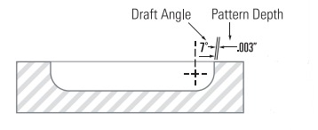

They successfully work with various tooling materials and offer advanced etchants for successful texture application. Mold surface finish recommendations ensure flawless texture patterns. The team's expertise extends to gloss reduction techniques and welding procedures for textured surfaces. In case of texture damage, their experienced repair technicians offer solutions to rectify the impairment. Standard tool materials such as P-20, H-13, S-7, 01, A1, A2, A6, 420 stainless, beryllium copper, kirksite, and both forged and cast aluminum have all be all been textured successfully. Advanced etch testing is currently being conducted on new 3-D printed / laser-sintered metals. To ensure your texture pattern shows cleanly without surface flaws, Mold-tech recommends the following surface finish on all areas to be textured: 400 emery finish for textures less than .001” in depth. 320 emery finish for textures greater than .001” in depth. With skilled craftsmanship, global capacity, and technical expertise, Standex Engraving Mold-Tech is the trusted world leader in providing superior texturing services.

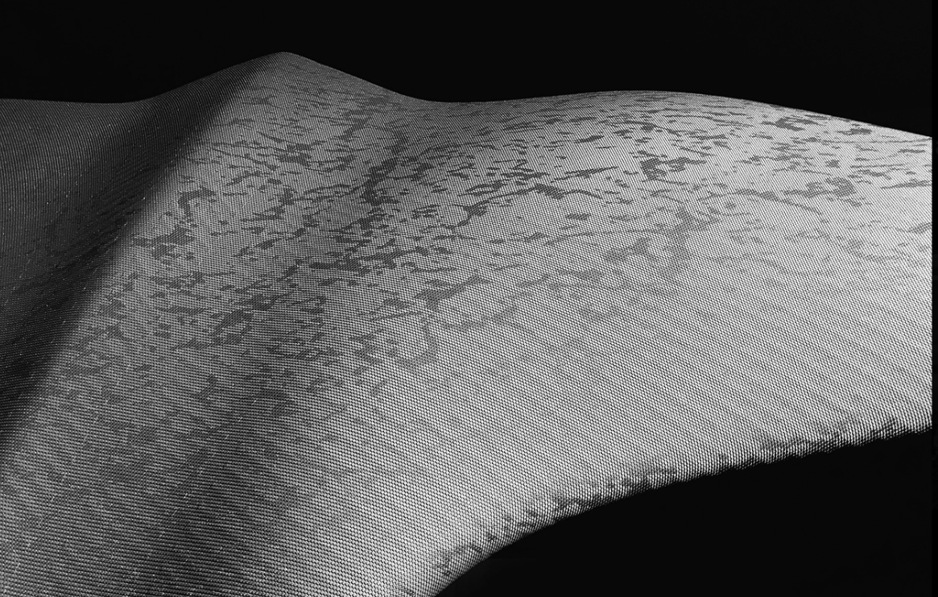

Figure Mold-tech texture sample (source : https://www.mold-tech.com/)

## Unique Features and Benefits of Mold-Tech Mold Textures

* Chemical engraving:

Standex Engraving's craftsmanship and advanced chemical engraving technology turn creative visions into reality. Seamlessly designed organic textures offer comfort, while precise patterns enhance functionality, providing limitless possibilities for distinctive product designs.

* Digital Transfer Technology (DTT):

Digital Transfer Technology (DTT) guarantees consistency, pattern integrity, and texture harmony around the world. Exclusive to Standex Engraving Mold-Tech, DTT machines use a digital pattern sourced from a global library to print in high resolution directly onto molds for similar results.

* Laser Technology:

Standex Engraving Mold-Tech is the exclusive global supplier of laser engraving, offering precise and sophisticated workmanship. Laser engraving provides superior features like multiple gloss levels, haptic touch effects, and optimized scratch performance. It allows flawless texture transitions, making it ideal for applications such as lens tooling that require jewelry-quality shimmer and brilliant results.

* Render-Tech:

Standex Engraving Mold-Tech's exclusive innovation, Render-Tech, precisely and seamlessly applies textures to complex surfaces. Similar to a custom-tailored suit, Render-Tech ensures textures fit every curve and turn flawlessly, maintaining proportion and dimension without any distortion.

## Applications and Industries Where Mold-Tech Mold Textures Are Commonly Used

* Automobiles
* Food packaging industry
* Plastic products
* Electronics
* Medical instruments

# Yick Sang (YS) Mold textures

## History and Background

Yick Sang was established in 1981 in Hong Kong. YS is one of the pioneers of mold texturing in China. Their unwavering focus on innovation and quality has earned them international recognition as a one-stop solution for mold texturing. YS textures are widely identified globally, especially in the automobile and electronic industries. Yick Sang has expanded its growth across China, boasting over 20 facilities and a dedicated workforce of more than 500 employees in South, East, and West China. This strategic expansion enables them to efficiently meet their client's diverse demands.

Yick Sang's professional team is dedicated to delivering superior textures at competitive prices and catering to the specific requirements of its clients. Their commitment to excellence and customer satisfaction has grown their company as a trusted and renowned brand in the mold texturing industry. Through their years of experience and continuous pursuit of improvement, Yick Sang remains a reliable partner for high-quality mold texturing solutions worldwide.

## Overview of Yick Sang mold textures

Yick Sang Mold Texture, backed by over 30 years of experience, excels in achieving precise textures for both simple and complex mold structures. Their skilled technicians offer a comprehensive range of texturing methods, including chemical etching, sandblasting, laser engraving, and more, ensuring high-quality and durable surface finishes. As a one-stop texture solution, Yick Sang caters to various industries, providing mold texturing for plastic injection molds and surface finishes for rollers or metal products. With their expertise and proficiency, Yick Sang is a trusted partner for clients seeking exceptional mold texturing services and superior surface finishes across a wide range of applications.

|  |  |
| --- | --- |
| Figure Yick Sang texture sample 1 | Figure Yick sang texture sample 2 |

## Unique Features and Benefits of Yick Sang Mold Textures

1. Chemical engraving and laser etching
2. More texture varieties
3. Customization options
4. Cheaper Price

## Applications and Industries where Yick Sang Mold Textures Are Commonly Used

* Automotive
* Mobile
* Household
* Electronic
* Office
* Medical instruments

# Mold-Tech VS YS: A Comparative Analysis

## Comparison of Texture Variety and Options

Yick Sang texture books offer a collection of 240 texture plaques from basic plastic textures to mimicking the materials like wood, leather, and floral patterns. In contrast, Mold-tech offers less range of collection of textures than Yick Sang. Their texture books contain 80 plaques. The Yick Sang Texture Book currently has three versions:

* 4 digits (YS1284)-Classic Version-240 plaques
* 5 digits (YS20031)-Published in 2019-110 plaques
* 6 digits (YS300000)–Published in 2020-120 plaques

Mold-Tech texture specifications:

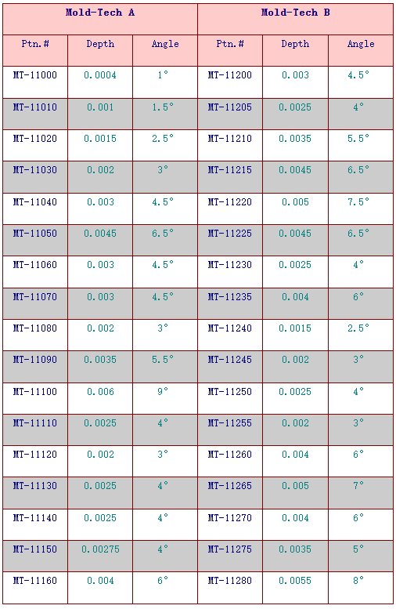

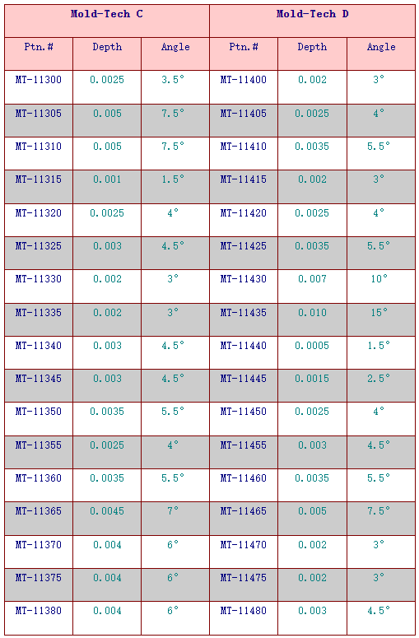

Yick sang texture specifications:

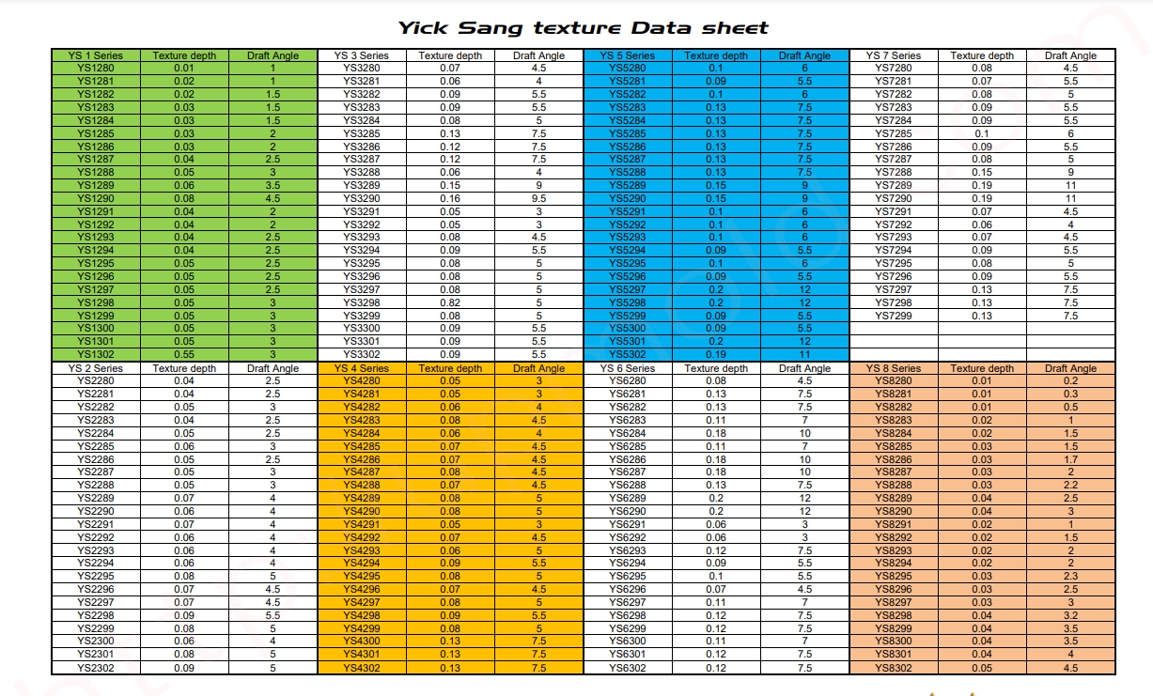For the Yick sang catalogue, go through this link: <https://upmold.com/wp-content/uploads/Data-center/Yicksang-Texture-fold.pdf>

## Comparison of Texture Quality and Durability

Mold Tech and Yick Sang are two companies that use identical methods for mold texturing to deliver reliable and consistent results for their clients. Both of these two companies exhibit clear definitions and a smooth surface finish. However, Mold Tech is more widely acceptable than YS by producing mold textures with premium looks of appearance. Their textures have an extra level of finesse and visual appeal, which makes them well-suited for applications that require surface refinement. Despite these differences, their durability depends upon the methods used for texturing.  Etching gives generally a more durable surface finish as the plateaus provide more bearing area meaning the wear reduces the height rather than the area. But, in spark eroded and blasted finish the tips are rounded so any wear flattens these off giving a noticeable change in appearance. The choice of selection between Mold Tech and Yick Sang for mold texturing would ultimately depend on project requirements, design preferences, and objectives. Yick Sang textures is a preferred choice for clients seeking a broader range of textures at cheaper prices while Mold Tech appeals to customers who need premium aesthetics and appearances for their product.

Top of Form

## Comparison of **Cost-Effectiveness**

When comparing Mold-Tech and Yick sang texture on the basis of cost-effectiveness, Yick sang is a way more budget-friendly choice. Yick sang textures standards not only matches the textures standards of Mold-Tech but also come at a significantly lower price. Yick sang textures are 3 to 10 times cheaper than Mold-Tech offerings. Therefore, Yick sang becomes an economically viable option compared to Mold-Tech due to its cost-effectiveness and satisfactory results.

## Comparison of **Customer Service and Support**

Mold Tech and Yick Sang have different approaches to customer service and support. Mold Tech, being a premium provider, excels in responsiveness and personalized assistance. They have 39 locations in 20 countries, which keeps them connected to clients across the countries. Their way of approaching customers is superior to Yick Sang. Their staff with technical expertise ensures comprehensive guidance for complex projects, and they may offer more unique designs, appealing to high-end customers. Moreover, Mold Tech's after-sales support aims to ensure customer satisfaction by addressing any post-installation concerns promptly. On the other hand, Yick Sang, with a wider customer base, has slightly longer response times to customers. They do not have a broader reach in different countries especially out of Asia like Mold-tech. While they may have the same level of specialization and tailored assistance as Mold Tech, Yick Sang still needs to upgrade in online portal such that customers have a platform to receive adequate support and assistance throughout their journey. While choosing one between Mold-tech and Yick Sang, customers should consider their specific needs, project complexity, and the desired level of support.

# Case Studies

In order to make the products strong, and tough using leather, stipple, animal, and wood, texturing is done. The explicit use of Mold-Tech and Yick Sang textures depends on market trends, customer preferences as well as industry requirements.

Real-world examples of products using Mold-Tech textures

Mold-Tech textures are usually preferred to be done on steel or aluminum molds after the mold cavity is milled. There are two textures: light textures (that incorporate a corrosive chemical on the tool) and complex textures (uses a 5-axis laser to etch into the mold). Mold-Tech textures are frequently used to provide excessive attention to detail for creating a high-quality appearance. This texturing offers smooth to highly intricate patterns, which is why Mold-tech falls on the higher end of the cost spectrum. Some real-life examples of products that use Mold-Tech textures are:

1. Smartphones, tablets, laptops, and gaming consoles
2. Automotive Grilles and Trims, washing machines, refrigerators, and microwaves.
3. Medical devices and power tools like drills, saws, and screwdrivers to provide a non-slip surface for better user handling.
4. Furniture and home decor for unique surface patterns.

## Real-World Examples of Products Using YS Textures

Yick Sang textures are considered to be economical while still maintaining good quality even at a lower price. Yick Sang Texture is the pillar of mold texturing in China which focuses on providing excellent grip and tactile experiences. Some real-life examples of products using Yick Sang textures are:

* Phone cases and blenders, juicers, for aesthetics.
* Routers, modems, door panels, and smart home devices for a premium appearance.
* Hairdryers, electric shavers, and toothbrushes may for better grip.
* Plastic toys and game components.

# Making the Right Choice: Factors to Consider

How to choose between Mold-Tech and Yick Sang based on project requirements

Some of the factors that can be considered while making a decision for choosing between mold tech and Yick Sang based on project requirements are explained below:

* Budget: You need to finalize your budget range before finalizing the decision. A you know, Mold-Tech textures are known for their premium appearance that comes with increased cost while Yick Sang textures are considered to be economical.
* Industry and Application: Depending upon the project and its area of application, you can make a selection between these two options. Mold-Tech is preferred in the high-end consumer goods industries, while Yick Sang are versatile that can cater to a broader range of products.
* Texture Complexity: As you know, Mold-tech can provide intricate and beautifully detailed textures whereas Yick Sang focuses on versatility.
* Regional Availability: This is the main point that can affect your selection. Depending on your manufacturing setup location, the accessibility to these texture companies may differ. If you are located in Asia, the clear-cut selection should be Yick Sang textures.

# Conclusion

Mold texturing is essential for the enhancement of the surface finish and aesthetics of the molded parts. Mold-Tech and Yick Sang are two companies that have been providing the texture for various industries. Mold tech offers a premium texture library with advanced technologies like DTT and laser engraving. On the other hand, Yick Sang provides economical yet high-quality textures for industries like mobile, household, and medical instruments. Mold tech is widely used in the US while Yick sang is popular in Asian countries. Both companies have made a name for themselves as trusted partners in the mold texturing industry, offering unique features and standards that are accepted globally. The choice of selection among these two depends upon the industry, budget, project complexity, and regional availability. Clients who seek budget-friendly options with varieties of textures should choose Yick Sang while Mold-tech is the first option for the premium appearance.